RUSSEL AND HELEN MISSURELI SCHOLARSHIP
2024

WHAT IS THE SCHOLARSHIP: The Russell and Helen Missureli Scholarship was created in 2010 to recognize the service they gave over many years to Roma Lodge, the church, and the community at large. The funds were donated by the family and friends of Russell and Helen Missureli on the occasion of Russell’s ninetieth birthday. In addition to community service, scholastic achievement will also serve as the basis for selection of a recipient. The scholarship awards a one-time payment of $1000 to a graduating high school senior who is the child of a Roma Lodge member. The scholarship can be applied to any course of study leading to a recognized associate or baccalaureate degree at any accredited United States college or university of the recipient’s choice. The application, selection, and award process for the scholarship is administered by Roma Lodge.

WHO IS ELIGIBLE: All graduating high school seniors, who are biological or adopted children of Roma Lodge members, are eligible to apply for the scholarship. An applicant’s father must be a member in good standing as of January 31st of the calendar year that application for the scholarship is made. The recipient’s father must continue to be a member in good standing for the duration of the scholarship academic year. Applicants must be planning to pursue a part-time or full-time program of study at a college or university in the United States. The recipient of the Missureli Scholarship will not be eligible to receive any other scholarships offered through Roma Lodge.

APPLICATION REQUIREMENTS: Applicants must demonstrate:
- Evidence of acceptance as a student in an associate degree or baccalaureate degree program.
- An exemplary record of community service as evidenced by a list of community, school, or church related activities.
- Academic achievement as evidenced by a full transcript of grades.
- Good character as evidenced by two letters of recommendation.

OBTAINING APPLICATION FORMS
Scholarship Application Forms can be downloaded as a Word document from the Roma Lodge Members web page, www.romalodge.com/members/scholarships or a form can be emailed to you.
Contact Frank Bisotti, Scholarship Committee Chair fbisotti@ameritech.net to request an email copy.

SELECTION CRITERIA: The recipients are selected by a panel of independent evaluators whom reside in Wisconsin. Roma Lodge officers or members do not take part in the selection of the recipients.
Selection is based on:
- Community service – 60%
- Academic achievement - 40%

Russell and Helen Missureli Scholarship- 2024
Page 2

ANNOUNCEMENT OF RECIPIENT
The recipient of the Russell and Helen Missureli scholarship will be selected by April 30th and notified by early May of each year the scholarships are offered. The recipient will be recognized at his/her spring high school scholarship awards ceremony, by a Roma Lodge representative, when possible.

SUBMITTING APPLICATION FORMS
Applications along with all supporting documentation must be received by March 29, 2024. Mail or deliver the applications to:
Roma Lodge Scholarship Committee
Attn: Frank Bisotti, Chairman
7130 Spring St
Racine, WI 53406

REAPPLICATION FOR THE SCHOLARSHIP
A recipient of the scholarship may NOT reapply for another year’s award.

DOLLAR VALUE AND PAYMENT OF SCHOLARSHIP
Roma Lodge will pay One Thousand dollars to the scholarship recipient upon receipt of a copy of
his/her: 1) formal acceptance to the college or university he/she will be attending and 2) high school diploma.
Copies of letter of acceptance and high school diploma should be sent to:
Roma Lodge Scholarship Committee
Frank Bisotti, Chairman
7130 Spring St
Racine, WI 53406

OTHER AWARDS
An individual cannot be the recipient of more than one of the two scholarships (Roma Lodge Merit, or Missureli) that Roma Lodge offers. Recipients may accept scholarships from other organizations

RECIPIENT OBLIGATIONS
Recipients are responsible for making entrance arrangements with their colleges and for fulfilling entrance requirements.
Upon completion of scholarship award time period: Recipients are required to submit:
- A letter explaining what they have achieved during the academic year of the scholarship.
- A transcript from the college in which they are enrolled listing courses and grades completed during the academic year.
.
2024 ROMA LODGE SCHOLARSHIP COMMIITTEE
Frank Bisotti, Chairman fbisotti@ameritech.net

The Russell and Helen Missureli Scholarship
2024 Application Form

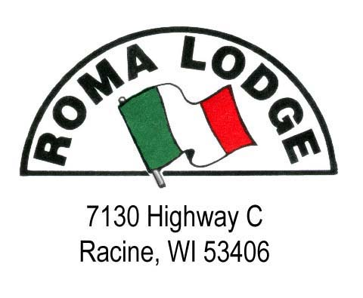

Date of Application _________________

APPLICANT NAME __________________________________________________________

HOME ADDRESS ___________________________________________________________

___________________________________________________________

___________________________________________________________

TELEPHONE ___________________________________________________________

EMAIL ___________________________________________________________

FATHER’S NAME ___________________________________________________________
(Biological or adoptive)

MOTHER’S NAME ___________________________________________________________

HIGH SCHOOL ATTENDING ____________________________________________________
Class rank at the end of last quarter ______
Cumulative grade point average ______

COLLEGE OR UNIVERSITY FOR WHICH SCHOLARSHIP WILL BE USED:
_________________________________________________________

DEGREE SOUGHT
______________________________________________________________

-1-
Russell and Helen Missureli Scholarship Application Form - 2024
Page 2

List your community, school, and church related service activities

List any honors, awards or other forms of recognition that may be appropriate for this scholarship

Russell and Helen Missureli Scholarship Application Form – 2024
Page 3

In a brief essay, explain why you believe you would be a suitable recipient of this scholarship (attach additional page if necessary)

Signature of Applicant ______________________________________________________

Submit the completed application and the following supporting information to the Scholarship Committee:

1. Official high school transcript of grades
2. Two letters of recommendation from individuals that are not related to the applicant
Note: Applications are not considered complete until all components are filed and applicant’s father’s status as a “member in good standing” is verified.
Completed applications with all attachments must be received by March 29, 2024
Deliver or mail to:
Roma Lodge Scholarship Committee
Attn: Frank Bisotti, Chairman
7130 Spring St
Racine, WI 53406

Revised February 9, 2024

